Create an EC2 instance and select the operating system as Ubuntu

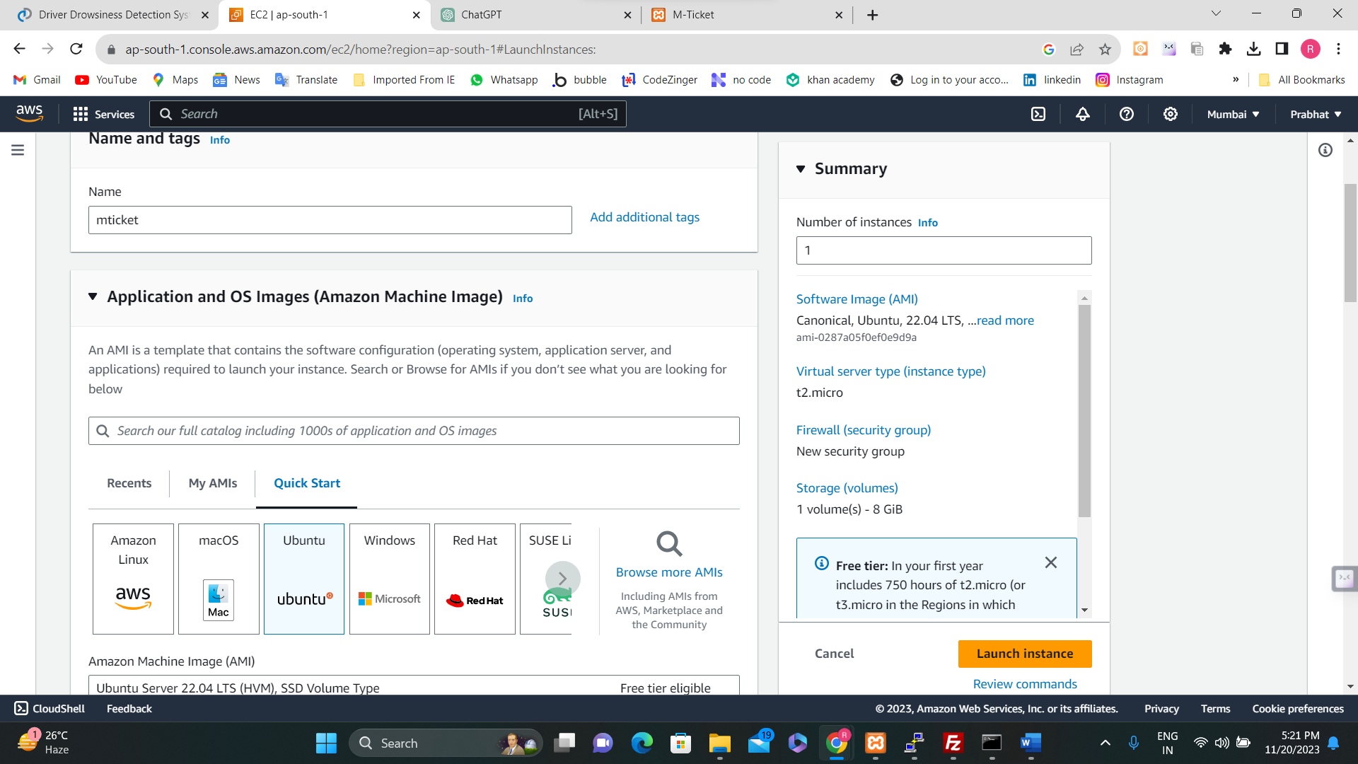

Create a new key-pair and allow HTTP traffic for the instance and then launch the instance

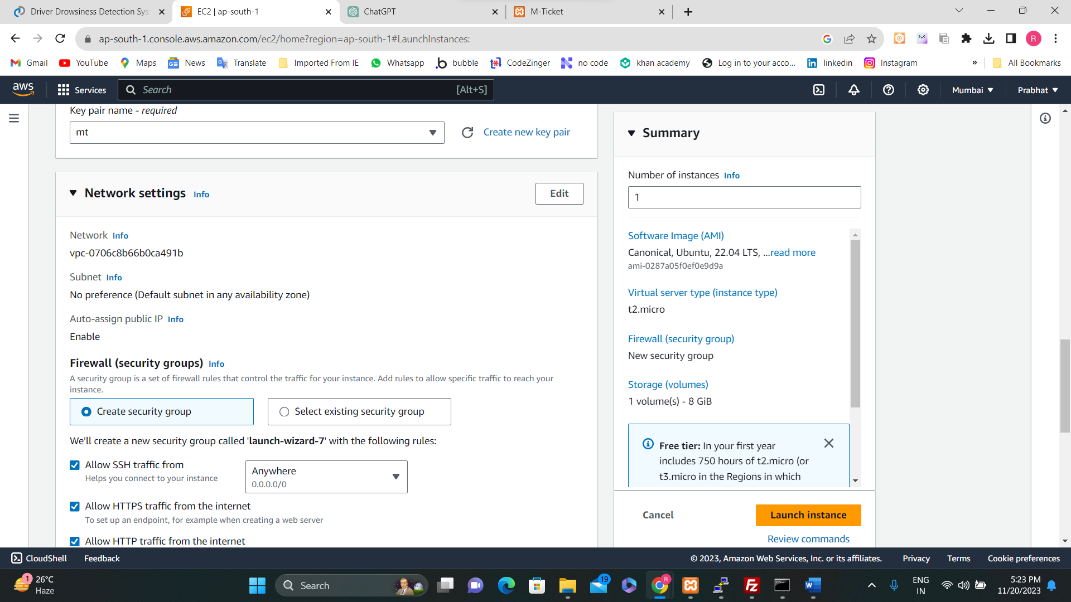

Then allocate a new Elastic IP

Now paste the IP of the instance and associate the Elastic IP to the instance

After all these steps, install PuTTY software from the Microsoft Store and open it.

Paste the hostname of the instance in it.

Then navigate to Connection/SSH/Auth/credentials and browse through the system and upload the key-pair and then press open

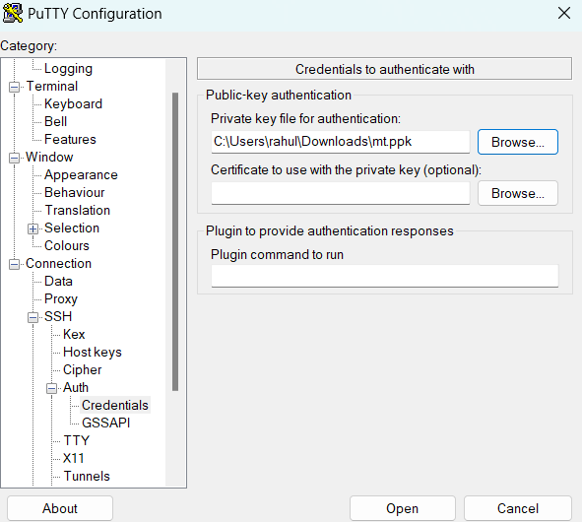

Now on your EC2 machine install XAMPP

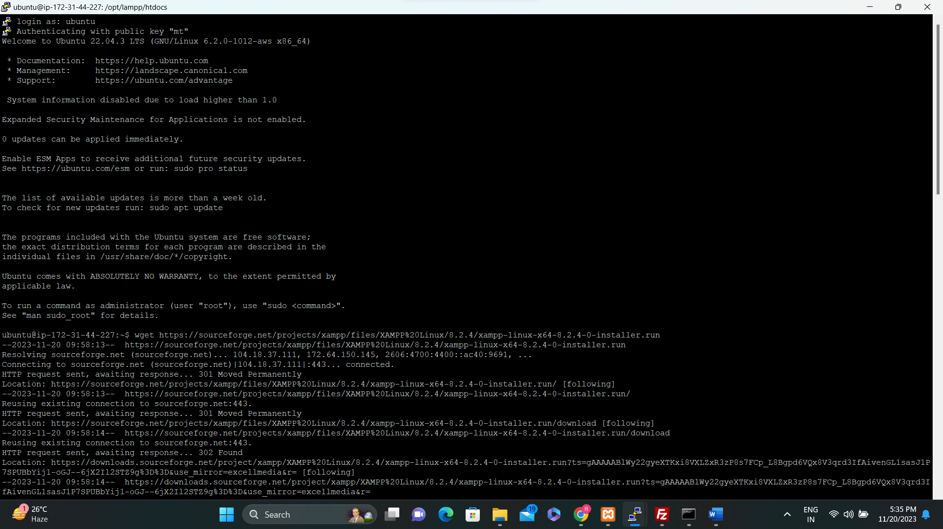

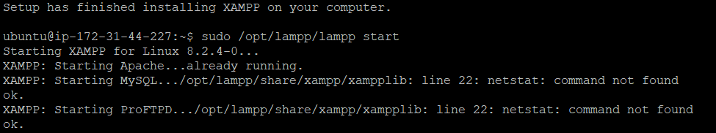

For uploading the files of our project we have used FileZilla

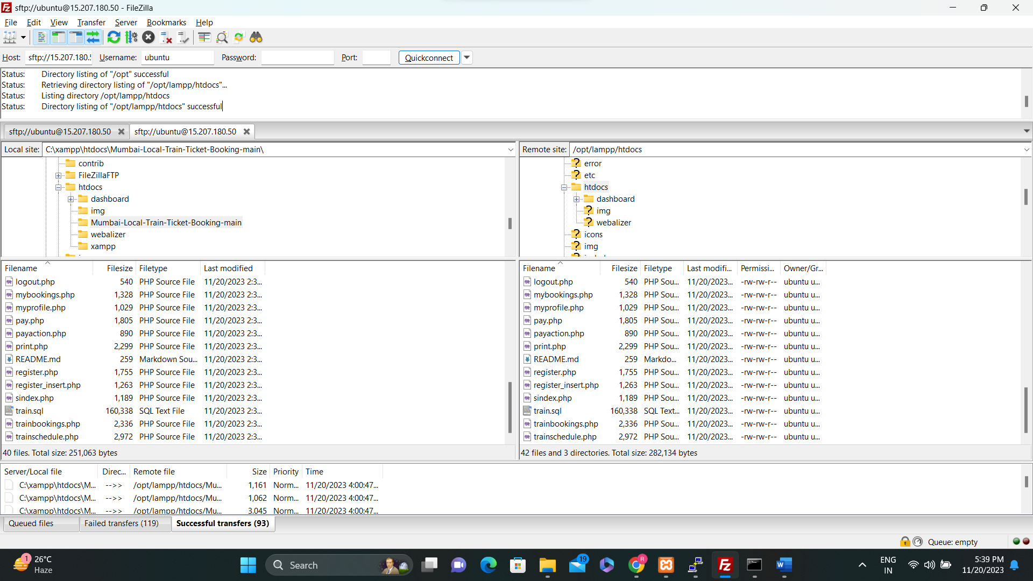

After all these steps our Project is finally working.

